Getting a Cell Phone

We recommend getting a cell phone from Metro by T Mobile. There are many locations across the state. The cost can range from $100 to $200 for a cell phone and the first month of service. They usually run different deals. The following are a few locations in New Haven. We recommend asking a friend or a family member for help finding a different location if these are not convenient.

Locations in New Haven

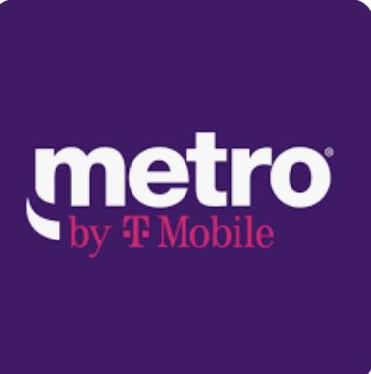

185 Grand Ave, New Haven, CT 06513 (FairHaven Neighborhood)

80 Church St, New Haven, CT 06510 (Downtown)

55 Whalley Ave, New Haven, CT 06511(Dwight Neighborhood)

**A few reminders**

* Your cell phone bill will need to be paid every month. You can go to a Metro By T Mobile store every month to pay OR if you have a debit or credit card you can pay through the account on your phone.
* Whatsapp can be used with wifi if your cell phone data is shut off.
* Associates at the stores are there to answer any questions about set up and your account. Don’t be afraid to ask questions.