How to communicate using Google Translate

Many places around New Haven have Spanish speakers available to communicate with the community. If they don’t they might have interpreters available via a phone line.

When this is not the case it is important to know how to communicate using translation technology widely available via smartphones. We recommend using Google translate.

Google translate can be accessed via the smartphone app or online at https://translate.google.com/
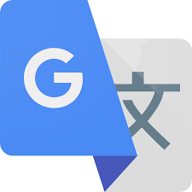

←This is what the ICON looks like on a smartphone.

Once you download the app or go to translate.google.com you can select the languages you need to communicate in.

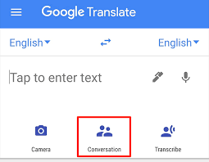
‘

Once you choose the languages you want, you can type in what you want to translate OR you can also select the CONVERSATION icon and speak to translate a conversation.

You can also take a photo of documents and have them translated.

SOME THINGS TO NOTE:
Translation is not always accurate but it is enough to understand the general points.
Always ask for clarification.

