Options for Transportation in the New Haven Area
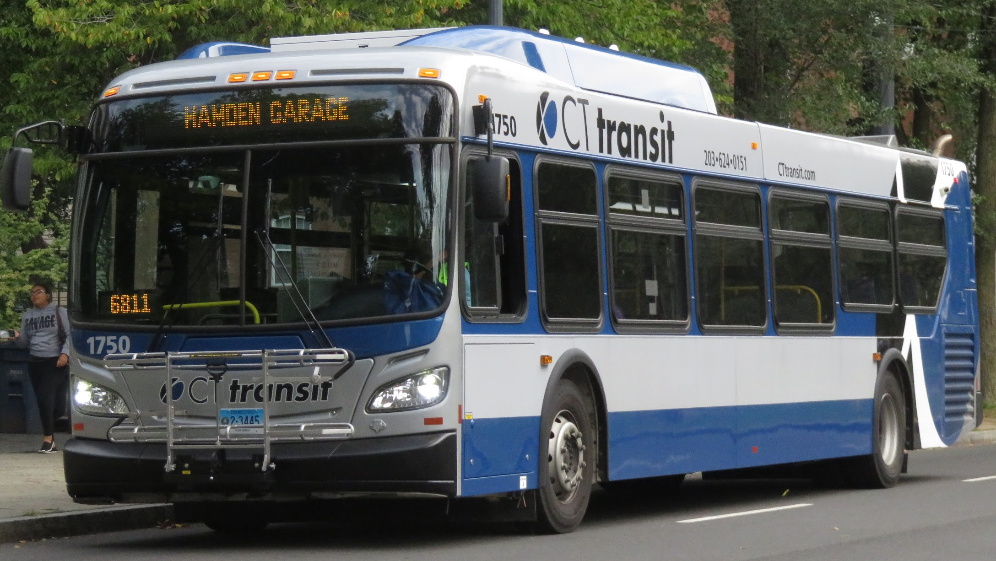
BUSES

The blue buses have designated stops all over New Haven and the state. Most buses stop at the New Haven Green located in the downtown area. The buses are free until March 2023.
If you have a smartphone, download the app TRANSIT to get directions to and from your destinations.

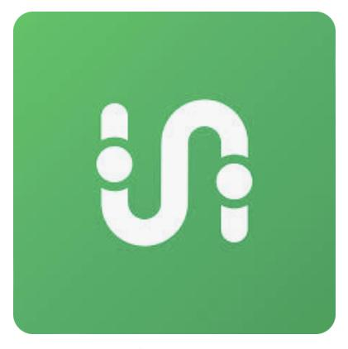
Go to your phone’s App store and download the TRANSIT app. The app is free. Once you download the app, enable location sharing. Input the address you would like to go to. The app will tell you what buses to take to get to your destination and approximately how long it will take to get there.

RIDESHARE APPS
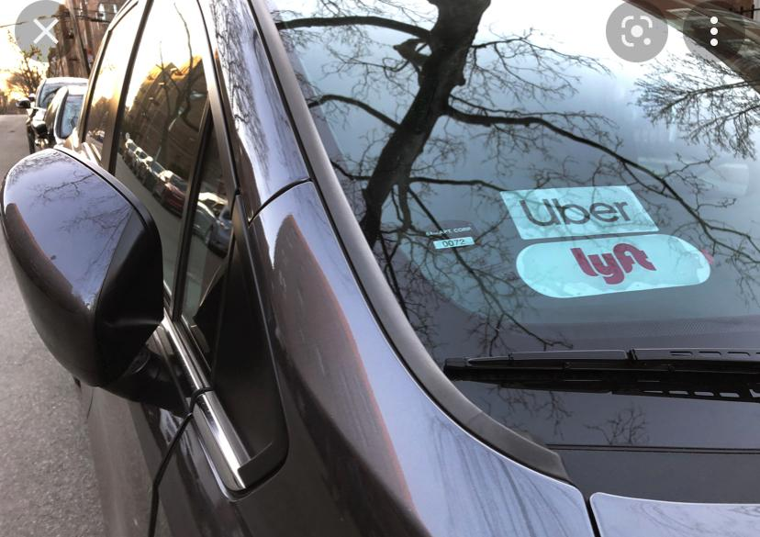
Ridesharing is a service that arranges one-way transportation on short notice. The two biggest ridesharing companies are Uber and Lyft. Using the app on a smartphone you can request a
ride from a local driver.

Go to your phone’s App store and download the LYFT or UBER app. The app is free. Once you download the app, enable location sharing. Input the address you would like to go to. The app will tell you how much it costs and how long it will take. You must have a credit card connected to the account. Once you complete a ride the money will be taken from your account

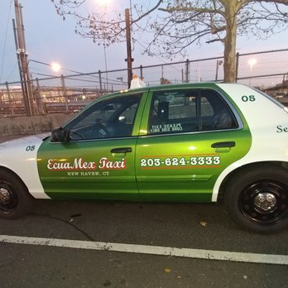
TAXI SERVICES:

Taxi services are available as another option for ridesharing to get to where you need to go. Most taxi services charge an initial fee (usually between 3-4 dollars) to start the ride, an additional 3-4 dollars per mile during the duration of the trip and usually a wait-time fee for however long it takes for you to get into the taxi after it arrives, usually around .30 - .50 cents per 30 seconds - 1 minute of waiting. Prices change based on which company is used as most have different rates. You can pay cash or card for these services, and there are some companies that speak Spanish (Ecuamex Taxi is one of these options). To arrange a ride, simply call any of the companies listed and tell them where you want to be picked up to begin your ride (most companies let you pay at the end of your trip).

Taxi Irlanda
845-327-3910
24 hour service

BUSES (continued):

ALL CT TRANSIT BUSES ARE FREE UNTIL MARCH 2023!

ALL CT TRANSIT BUSES STOP DOWNTOWN WITHIN THEIR ROUTE AT SOME POINT!

Bus stop signs look like this:
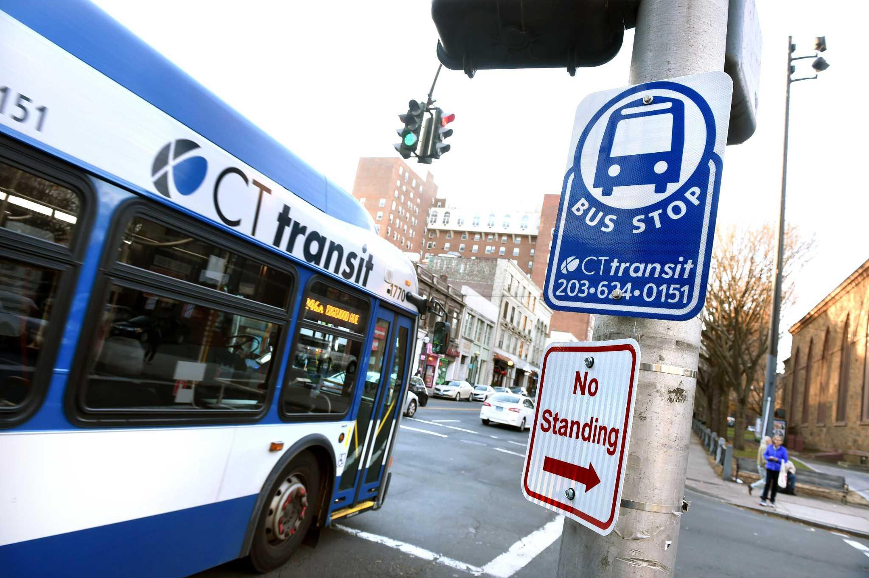

Some, but not all bus stops have shelter while you wait (mostly more popular lines / stops have this):
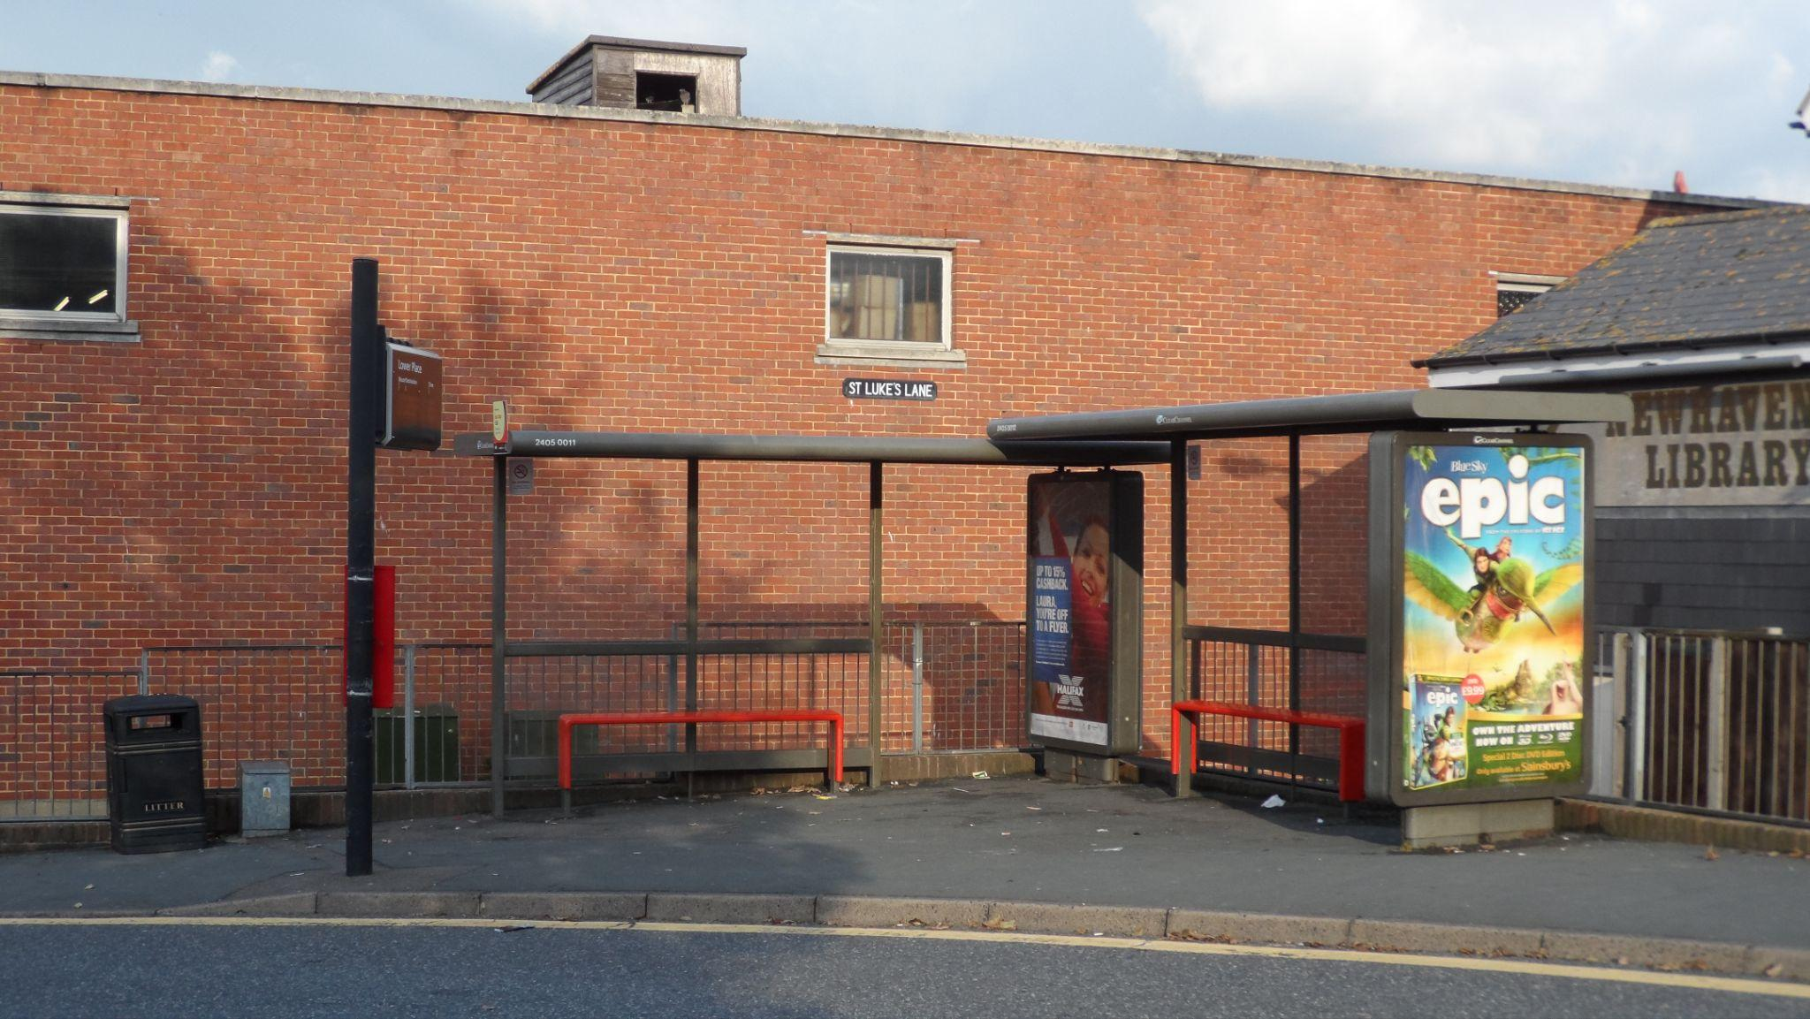

Bus routes are determined based on the letter name of the bus (for example, the J bus specifically goes all throughout Whitney Avenue).
