235 Nicoll Street Second Floor
New Haven, CT 06511

25 Main, Street
Hartford, CT 06106

TELEPHONE: (203) 562-2095
FAX: (203) 562-1798
EMAIL: info@irisct.org
WEB: irisct.org

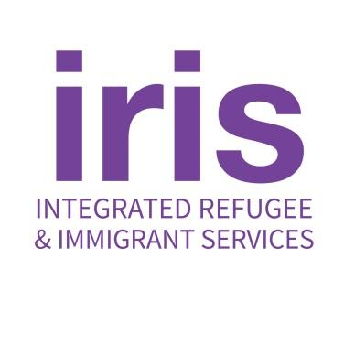
Job Announcement
Benefits Specialist – Full-time
IRIS (Integrated Refugee & Immigrant Services, Inc, www.irisct.org) is a dynamic refugee resettlement agency based in Connecticut, working in the New England Region and nationally, with a main office in New Haven and a satellite office in Hartford. IRIS serves people from all over the world who have fled persecution in their home countries to start new lives and become self-sufficient, enriching their new communities.
General Description
As an integral part of the Ukrainian Program Team and in support of the broader Case Management Team as an internal expert, the Benefits Specialist (BS) works to assist Ukrainian Humanitarian Parole (UHP) and Refugee newcomers, IRIS staff, and the communities around Connecticut that support the newcomers as they seek refuge in the U.S. The BS works with the Ukrainian Program Team to quickly and efficiently apply for public benefits for which clients are eligible - Husky Health Insurance, SNAP and Cash Assistance. The BS is part of a team providing direct services to the UHP and refugee newcomers, coordinating and tracking service provision via internal referrals, as well as entering case data into various required databases for tracking of services provided to clients
Essential Duties and Responsibilities include:
- Learn all DSS benefits application processes for UHP, refugee, and asylee clients, becom an internal expert at IRIS for troubleshooting benefits issues across all programs
- Develop and maintain excellent working relationships with all relevant DSS liaisons, including the State Refugee Coordinator
- Develop and maintain excellent working relationships with relevant IRIS program staff to facilitate training and understanding of benefits issues
- Assist Case Managers in the Ukrainian Program by applying for DSS benefits (SNAP/cash) and Access Health CT health insurance (HUSKY) for new clients following the initial intake by the Case Managers.
- Assist clients in renewing their DSS benefits and reporting changes as needed
- Troubleshoot application and benefits issues with liaisons at DSS
- Collect and log all documentation for DSS/AHCT applications
- Log case notes regarding the application, receipt and issues related to these benefits
- Participate in bi-weekly case review with Ukrainian Program Manager and other program staff, as needed to develop smoother benefits processes
- Other related tasks as assigned

Key Attributes
- Positive, solution-oriented personality and style
- Familiarity with applications to social services and DSS benefits
- Exceptionally organized and flexible
- Thrives in grassroots, start-up style organizational culture
- Commitment to maintaining confidentiality and exceptionally high quality standards
- Dedication to serving the immigrant community and to being a part of an anti-racist organization

Professional Requirements
- Proficiency in Microsoft Office and Google Suite
- Fluency in spoken and written English and strong communication skills
- Ability to handle multiple demands and shifting priorities in a fast-paced environment
- Awareness and sensitivity to multicultural issues and a demonstrated commitment to the
mission of IRIS
- Ability to occasionally work evenings
- Proficiency in or ability to learn and use various software platforms

In submitting an application for employment, the applicant grants IRIS permission to check references as well as question anyone who might be familiar with the candidate’s job performance.

Other Requirements
- At least 2 years of case management experience or personal experience of refugee
resettlement and 5 years of other professional experience
- Minimum 2 - 4 years professional experience
Compensation: $51,000 - $53,560 annually, full-time, salaried, 40 hours
Benefits: Health, dental, vision insurance. Life and disability insurance.
Vacation (3 weeks); personal days (3 per year); sick days, holidays per IRIS schedule Eligible for 403b retirement plan after 1 year.
IRIS is an affirmative action-equal opportunity employer.
To apply, send an email to humanresources@irisct.org with the following: Subject line of “Benefits Specialist- Your Name”
A cover letter and resume.
3 professional references
Applications will be reviewed in the order they are received and until the position is filled. No phone calls will be accepted.

