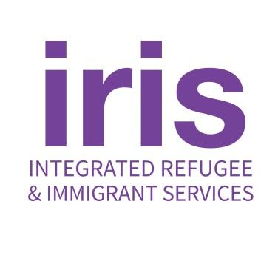
235 Nicoll Street Second Floor
New Haven, CT 06511

25 Main Street
Hartford, CT 06106

TELEPHONE: (203) 562-2095
FAX: (203) 562-1798
EMAIL: info@irisct.org
WEB: irisct.org

Job Posting
Office Manager- Full-Time, Hartford

IRIS (Integrated Refugee & Immigrant Services, Inc. (www.irisct.org) is a dynamic refugee
resettlement agency with offices in New Haven and Hartford, and on-going resettlement efforts
throughout the state and across the U.S. IRIS serves people from all over the world who have
fled persecution in their home countries to start new lives and become self-sufficient,
contributing members of their new communities.

Job Summary & General Responsibilities:

The Office Manager will work to support the IRIS Hartford Office with administrative and janitorial tasks such as welcoming visitors, handling mail, maintaining office organization and cleanliness. The Office Manager will take the lead on distribution of both seasonal and perpetual items such as winter clothing, school supplies, bicycles and diapers. The Office Manager will work to maintain a welcoming and functional office environment and to ensure both client and staff needs in relation to the office environment are supported.

This position is grant-funded. Grants typically fund for a period of one year. Extension grant-
funded employment is subject to the availability of funds.

In submitting an application for employment, the applicant grants IRIS permission to check references as well as question anyone who might be familiar with the candidate’s job performance.
Specific Duties:
- Open the office for business daily by following opening procedures
- Ensure the office is properly secure throughout each day
- Review and distribute voicemails and mail daily to appropriate staff
- Take daily stock of office supplies and maintain inventory
- Order and restock office supplies as needed and submit receipts for disbursement
- Greet and welcome all visitors to the office including clients and people in the community
- Set up and maintain a neat and orderly reception and hospitality area
- Develop and maintain relationships with community partners by performing outreach and responding to solicitations for information about IRIS to and from community partners
- Answer phone calls and take messages or connect visitors with staff as needed
- Maintain vehicle use logs and manage vehicle maintenance needs, including scheduling oil changes and addressing service needs
- Maintain credit card log, secure staff credit cards and manage credit card distribution
- In close cooperation with the program staff, meet the daily needs of operating a fully functioning office including communicating and troubleshooting issues as they arise
- Perform and/or supervise daily light surface cleaning of all office spaces including the bathroom and kitchen areas and a once weekly deep cleaning of all office spaces
- Close the office daily according to closing procedures
- Collaborate closely with the office property management and landlord
- Assist with distribution efforts of seasonal and perpetual items such as winter clothing, school supplies, bicycles and diapers by collaborating with case managers and staff, organizing and maintaining spreadsheets, performing outreach, and facilitating volunteer support
- Prepare office essentials and desk space for new employees
- Other tasks as assigned
- Lived experience desired

Supervises: Interns, Office Cleaner, and volunteers as assigned
Reports to: Hartford Office Director
Compensation: This is a full-time, hourly (40 hours per week). The hourly range for this position is $20.93 - $22.93.
Benefits: Health, vision, dental, life and disability insurance. vacation (3 weeks/year), personal
days (3 days/year), holidays per IRIS schedule, sick leave. Eligible for 403b retirement plan after
1 year.

Diversity and inclusion are hardwired into IRIS’ mission: We are dedicated to welcoming
peoples from all over the world who are fleeing persecution, war, and violence. We are more
effective at serving our client’s needs when we are representative of the communities we live in
and work with. So we are an enthusiastic Equal Opportunity Employer. We strongly encourage
people from underrepresented groups to apply. Please reach out if you need accommodations in
applying.

To apply, send an email to humanresources@irisct.org as soon as possible with the following:
- A subject line that says “Office Manager - YOUR NAME”
- A cover letter
- An attached resume
- Three professional references (at least two direct supervisors)

Applications will be reviewed as they are received and will continue to be accepted until the position is filled and no phone calls are accepted.

