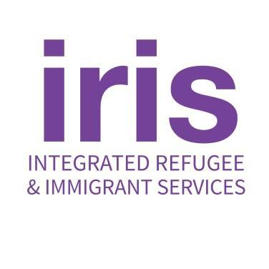
235 Nicoll Street Second Floor
New Haven, CT 06511
25 Main Street
Hartford, CT 06106
TELEPHONE: (203) 562-2095
FAX: (203) 562-1798
EMAIL: info@irisct.org
WEB: irisct.org

Pashto Teacher - Part-time

IRIS is a non-profit organization whose mission is to help refugees and other displaced people establish new lives, strengthen hope, dare to dream, and contribute to the vitality of communities in Connecticut and across the country. We also provide support to Americans who are sponsoring refugees for resettlement.
In welcoming peoples fleeing persecution and conflict, we are honoring our national heritage as a country of immigrants as well as our commitments under U.S. and international law. IRIS helps newcomers with services and support critical to their transition to self-sufficiency and to making local communities across the U.S. their home.
IRIS seeks to hire a High School Pashto Teacher for a partnership with New Haven Public
Schools. The teacher will work with two classes of native/heritage speakers of Pashto, one class
at Wilbur Cross High School and the other at Hillhouse High School. This is a new program with
the goal of advancing the reading and writing skills in Pashto for native/heritage speakers. The
ideal candidate will have several years of experience teaching Pashto or teaching another subject
in Pashto.

This position is grant-funded. Grants typically fund for a period of one year. Extension grant-
funded employment is subject to the availability of funds.

Key Responsibilities:

- Conduct pre-assessments to determine student abilities
- Design and implement engaging, student-centered course curriculum
- Seek and/or create appropriate teaching materials
- Provide differentiated instruction in reading and writing to meet the needs of students at different levels
- Maintain a welcoming, encouraging, and affirming classroom environment
- Assign appropriate classwork, homework, projects and informal and formal assessments
- Review and re-evaluate student needs and progress on an ongoing basis
- Provide regular student feedback
- Communicate regularly with parents, co-teachers, school administrators, and IRIS staff grading and other required documentation of student progress
- Create the best possible learning environment for students by addressing challenges proactively and communicating well with both school and IRIS staff
- Participate in NHPS World Language meetings and IRIS Education Team meetings as possible; support other educational programs and initiatives as needed
- Perform other duties as assigned by the Supervisor

In submitting an application for employment, the applicant grants IRIS permission to check references as well as question anyone who might be familiar with the candidate’s job performance.
Requirements | Candidates must have:
- Bachelor’s Degree required; teacher certification preferred
- Teaching Experience
- Effective classroom management
- Familiarity with culturally and emotionally responsive teaching methods
- Experience working with 14 to18 year olds in an educational setting
- Patience and flexibility
- Strong presentation, communication, and people skills
- Ability to work collaboratively
- Experience with refugees, asylees, and other immigrants
- Outstanding time management and organizational skills
- A commitment to anti-racism, cultural sensitivity, and the mission of IRIS
- Ability to travel around New Haven (a Connecticut Driver’s license and transportation are essential)
- Fluency in spoken and written Pashto
- Proficiency in spoken and written English
- Lived experience desired
Coaching Support by: NHPS World Languages Supervisor

Reports to: IRIS Manager of Education Support Services
Compensation: This is a part-time, hourly position averaging 15 hours per week during the school year (August 2024-June 2025); the pay range for this position is $20.50 - $22.50 per hour (for an uncertified teacher)

Benefits: PTO, vacation and sick leave.
Diversity and inclusion are hardwired into IRIS’ mission: We are dedicated to welcoming
peoples from all over the world who are fleeing persecution, war, and violence. We are more
effective at serving our client’s needs when we are representative of the communities we live in
and work with. So we are an enthusiastic Equal Opportunity Employer. We strongly encourage
people from underrepresented groups to apply. Please reach out if you need accommodations in
applying.

To apply, send an email to humanresources@irisct.org as soon as possible with the following:
- A subject line that says “Pashto Teacher-YOUR NAME”
- A cover letter
- An attached resume
- Three professional references (at least two direct supervisors)

Applications will be reviewed as they are received and will continue to be accepted until the position is filled and no phone calls are accepted.

